

Data Structures and Algorithms (23CSE203)
LAB MANUAL
Submitted By:
Name | MAHESWARAN R
Roll No | AV.SC.U4CSE25127
Year/Sem/Section | 2 nd YEAR /SEM-3/CSE-B
Date of Submission
Submitted To:
Name | Dr. Raj Kumar Batchu
Department | CSE
Designation | Assistant Professor, School of Computing

INDEX
SNO | LAB PROGRAM | PAGENO | REMARKS
1. | 1a. Recursive countdown from n to Launch.  1b. Recursive calculation of compound growth factor.  1c. Recursive search for employee ID in list.  1d. Recursive factorial calculation for parcel arrangements.  1e. Recursive Fibonacci series generation.
2. | 2a. Write a python program to perform linear search on the give input.  2b. Write a python program to perform binary search on the given. Verify by taking sorted array and unsorted array as an input.
3. | 3a. Write a program to perform Bubble Sort technique on the user given input.  3b. Write a program to perform Insertion Sort technique on the user given input.  3c. Write a program to perform Selection Sort technique on the user given input.
4. | 4a. Write a program to perform Merge Sort technique on the user given input.  4b. Write a program to perform Quick Sort technique on the user given input.
5. | 5a. Write a python program to implement a single linked list which would perform the below operations, by taking an input from the user.  5b. Write a python program to implement a double linked list which would perform the below operations, by taking an input from the user.  5c. Write a python program to implement a circular linked list which would perform the below operations, by taking an input from the user. Also add these two options accordingly.

6. | 6a) Write a python program to implement a stack using an Array Implement the stack operations such as push, pop, peak and also display the stack elements.  6b) Write a python program to implement a stack using an Array Implement the stack operations such as push, pop, peak and also display the stack elements.
7. | 7a) write a python program to implement queue and its operation such as enqueue, dequeue, peek, and display with a menu driven approach using array and linked list data structures.  7b) write a python program to implement queue and its operation such as enqueue, dequeue, peek, and display with a menu driven approach using circular queue.
8. | 8a. Write a python program to implement binary tree using array.  8b. Write a python program to implement binary tree using linked list.
9.
10.
11.
12.
13.

LAB-1
1a)Aim:- A rocket launch system displays a count down before launch. Instead of using a loop implement the count down using a recursion ,write a recursive program to display a count down from n to 1 followed by “Launch”
CODE:
def countdown(n):
if n==1:
return "LAUNCH"
return countdown(n-1)
n=int(input("enter the value of n:"))
print(countdown(n))
OUTPUT:
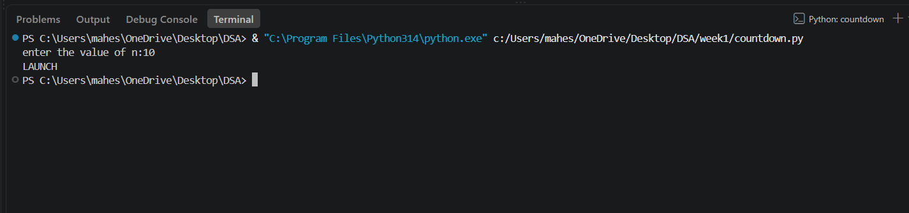
Explanation:
· The function launch(n) prints the current value of n.
· If n is greater than 0, it decreases n by 1 and calls itself recursively.
· The recursion continues until n becomes 0, which is the base case, and the function stops.
Error Table:
No errors

1b)Aim: An Hr department stores employee ID in a list. Develop a recursive program to search for a given employee ID write a recursive function to search for an employee ID. Write a recursive function to search for an employee ID in a list.
CODE:
def search(i):
l=[1001,1002,1003,1004,1005]
for j in range(len(l)):
if l[j]==i:
return j,i
else:
return("emp id not found")
return search(i)
i = int(input("enter the id to be searched:"))
print(search(i))
OUTPUT:
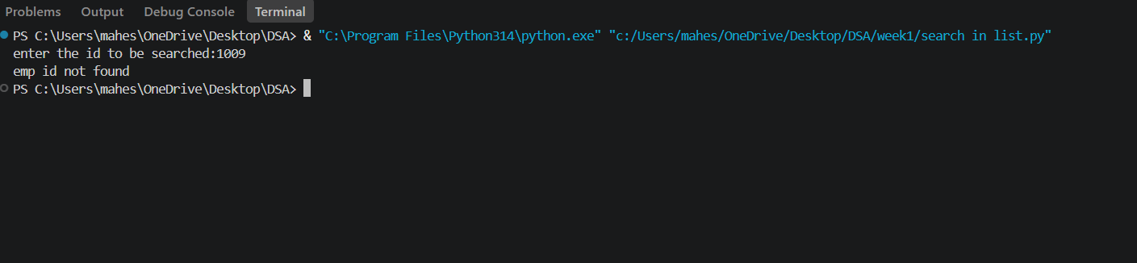
EXPLANATION:
This program uses recursion to perform a linear search for an employee ID (or any target element) in a list.
- The function empid_Search(arr, target, n=0) is defined with three parameters:
  - arr: The list in which the search is performed.
  - target: The element to be searched.
  - n: The current index, initialized to 0.
- The statement if n == len(arr): return -1 is the base condition. It checks whether all elements in the list have been examined. If the end of the list is reached without finding the target, the function returns -1.
- The statement if arr[n] == target: return n compares the current element with the target. If they are equal, the function returns the current index where the target is found.
- If the current element does not match the target, the function calls itself recursively with the next index using return empid_Search(arr, target, n + 1).
- The list arr = [10, 20, 30, 50, 607, 809, 506] is created, and the function is called to search for the element 50.
- The returned value is stored in the variable result.
- If result is not equal to -1, the program prints the index where the element is found. Otherwise, it prints "Element not found."

ERROR TABLE:
No errors

1c)Aim: Banks calculate the growth of an investment using compound interest. The formula requires calculating powers, which can be implemented recursively. Write a recursive program to calculate power.
CODE:
def pow(p,n):
if n==0:
return 1
return p*pow(p,n-1)
p=int(input("enter the value of p:"))
n=int(input("enter the value of n:"))
print(pow(p,n))
OUTPUT:
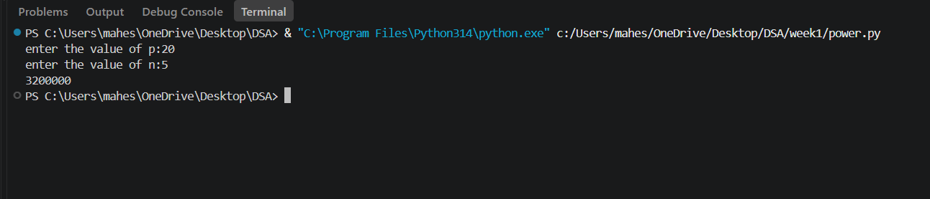
EXPLANATION:
- The program is used to find the power of a number (pⁿ) using recursion.
- It takes two inputs from the user:
- p → Base number
- n → Exponent (power)
- The function power(p, n) is called to calculate the result.
- If the exponent n is 0, the function returns 1 because any number raised to the power 0 is
- If n is not 0, the function calls itself with n - 1 and multiplies the result by p.
- This recursive process continues until the exponent becomes 0.
- After reaching the base case, each recursive call returns its result, and the final value of pⁿ is obtained.
- The result is stored in the variable result.
- Finally, the program prints the calculated power of the given number.
ERROR TABLE:
No errors
1d)Aim: Write a recursive python program for fibanocci series , print first n terms series.
CODE:
def fibbanacci(n):
if n<=1:
return 1
return fibbanacci(n-1)+ fibbanacci(n-2)
n=int(input("enter the value of n:"))
for i in range(n):
print(fibbanacci(i),end="")
OUTPUT:
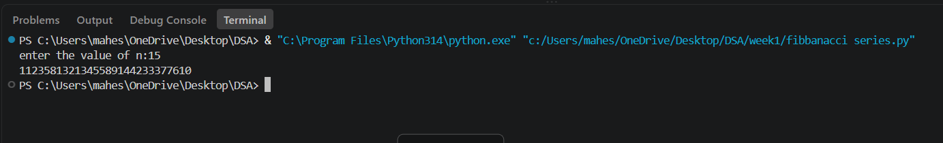
EXPLANATION:
- The program uses a recursive function fib(n) to generate Fibonacci numbers.
- The base condition returns 0 when n = 0 and 1 when n = 1.
- For values greater than 1, the function returns the sum of the previous two Fibonacci numbers: fib(n-1) + fib(n-2).
- The user enters the number of terms (n) to be displayed.
- A for loop calls the fib() function repeatedly for each term from 0 to n-1.
- Finally, the program prints the Fibonacci series in sequence.
ERROR TABLE:
Error | Correction
Function name spelling | Change it to fibonacci.
Negative input | Check that n >= 0 before running the loop.

1e)Aim: In a logistic company , the number of possible ways to arrange n different parcels is calculated using the factorial formula (n!) , develop a recursive program to calculate factorial of a given number.
CODE:
def fact(n):
if n == 0 | n == 1:
return 1
return n* fact(n-1)
n= int (input("enter the value:"))
print(fact(n))
OUTPUT:
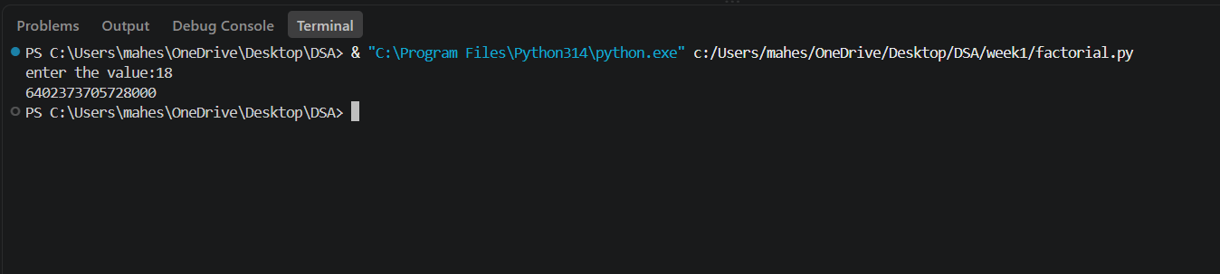
EXPLANATION:
- The program defines a recursive function fact(n) to calculate the factorial of a number.
- The base condition checks if n <= 1. If true, it returns 1 (for factorial, 0! = 1 and 1! = 1).
- Otherwise, the function returns n * fact(n-1), multiplying the current number by the factorial of the previous number.
- The function is called with the value 6.
- Finally, the program prints the factorial of 6, which is 720.
ERROR TABLE:
Error | Correction
Indendation error | Give proper indendation
Negative input | Check that n >= 0 before running the loop.

LAB-2
2a)Aim: - Write a program to perform linear search on the given input.
CODE:
def linear_search(arr,key):
for i in range (len(arr)):
if arr[i] == key:
return i
return -1
n = int (input("enter number of elements:"))
arr = []
print("enter the elements:")
for i in range(n):
arr.append(int(input()))
key = int(input("enter the element to search"))
result = linear_search(arr,key)
if result != -1:
print("element found at index", result)
else:
print("element not found in the array")
OUTPUT:
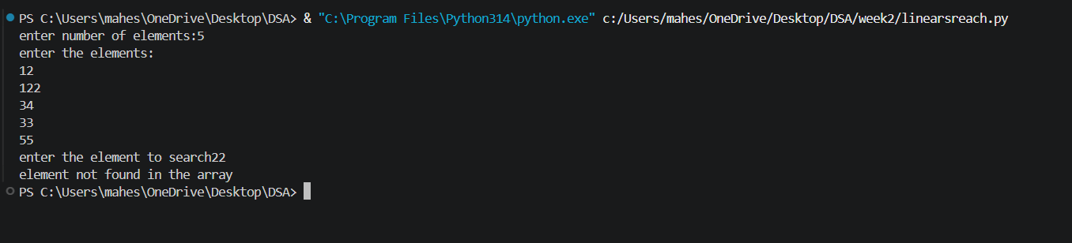
EXPLANATION:
This program uses a linear search technique to find a target element in a list.
- The function linear_search(arr, target) is defined with two parameters:
  - arr: The list in which the search is performed.
  - target: The element to be searched.
- A for loop is used to traverse each element of the list from index 0 to len(arr) - 1.
- The statement if arr[i] == target: compares each element of the list with the target element.
- If the element is found, the function returns "at position", i + 1, which gives the position of the element (starting from 1).
- If the loop completes without finding the element, the function returns "element not found".
- An empty list a is created, and the user is asked to input elements continuously.
- The loop continues until the user enters "stop", after which the input process ends.
- The user then enters the element to be searched, which is stored in variable b.
- The function is called using linear_search(a, b) and the result is printed.

ERROR TABLE:
Error | Correction
Indendation error | Give proper indendation
Negative input | Check that n >= 0 before running the loop.
  Empty array
  Check that n > 0.

2b)Aim: Write a python program to perform binary search on the given input verify by taking sorted array and unsorted array as input:
CODE:
def binary_search(arr,target):
low=0
high=(len(arr))-1
while low<=high:
mid=(low+high)//2
if arr[mid]==target:
return "at position",mid
elif target>arr[mid]:
low,high=mid+1,high
else:
low,high=low,mid-1
a=[]
while True:
elem=input("Enter a element(or enter stop to finish):-")
if elem.lower()=="stop":
break
a.append(int(elem))
b=int(input("Enter the element that is to be found:-"))
a.sort()
print(binary_search(a,b))
OUTPUT:
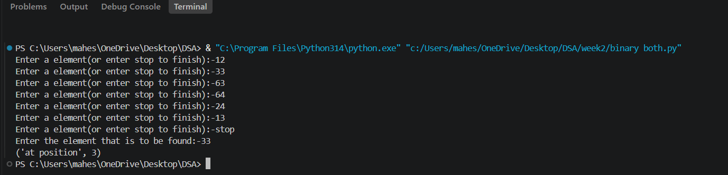
EXPLANATION:
This program uses the binary search technique to find a target element in a list.
- The function binary_search(arr, target) is defined to perform the search operation.
- Two variables are initialized:
  - low = 0: Represents the starting index of the list.
  - high = len(arr) - 1: Represents the last index of the list.
- A while loop runs as long as low <= high, ensuring the search space is valid.
- The middle index is calculated using mid = (low + high) // 2.
- The statement if arr[mid] == target: checks whether the middle element is equal to the target.
  - If true, the function returns "at position", mid.
- If the target is greater than the middle element (target > arr[mid]), the search continues in the right half by updating low = mid + 1.
- Otherwise, the search continues in the left half by updating high = mid - 1.
- The user inputs elements into the list a until "stop" is entered.
- The list is sorted using a.sort().
  - This ensures that even if the user enters an unsorted array, the binary search will still work correctly.
- The user enters the element to be searched, stored in variable b.
- The function is called using binary_search(a, b) and the result is printed.
ERROR TABLE:
Error | Correction
Indendation error | Give proper indendation
Empty array | Check that n >= 0 before running the loop.

LAB-3
3a) Write a python program to implement bubble sort where the elements are taken from the user.
CODE:
def bubble_sort(arr):
n = len(arr)
for i in range(n - 1):
for j in range(n - 1 - i):
if arr[j] > arr[j + 1]:
arr[j], arr[j + 1] = arr[j + 1], arr[j]
return arr
arr = []
z = int(input("Enter the number of elements: "))
for k in range(z):
arr.append(int(input("Enter the element: ")))
#bubble_arr = arr.copy()
print("Original array:", arr)
print("Sorted array:", bubble_sort(arr))
OUTPUT:
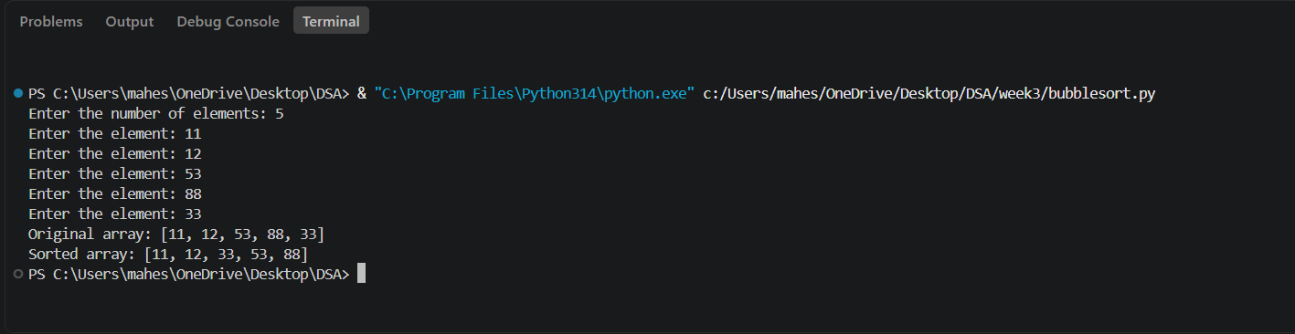
EXPLANATION:
- Bubble Sort is a simple comparison-based sorting algorithm.
- It repeatedly compares adjacent elements in the array.
- If two adjacent elements are in the wrong order, they are swapped.
- After each pass, the largest unsorted element moves to the end.
- The variable i controls the number of passes through the array.
- The variable j is used to compare adjacent elements.
- The comparison range decreases after every pass.
- The process continues until all elements are arranged in ascending order.
- Its time complexity is O(n²) in the best, average, and worst cases for this implementation.
- The function returns the sorted array after completing all passes.
ERROR TABLE:
No error
3b,Write a python program to implement insertion sort where the elements are taken from the user.
CODE:
def insertion_sort(arr):
for i in range(1, len(arr)):
key = arr[i]
j = i - 1
while j >= 0 and arr[j] > key:
arr[j + 1] = arr[j]
j -= 1
arr[j + 1] = key
return arr
arr = []
z = int(input("Enter the number of elements: "))
for k in range(z):
arr.append(int(input("Enter the element: ")))
arr = arr.copy()
print("Original array:", arr)
print("sorted array:", insertion_sort(arr))
OUTPUT:
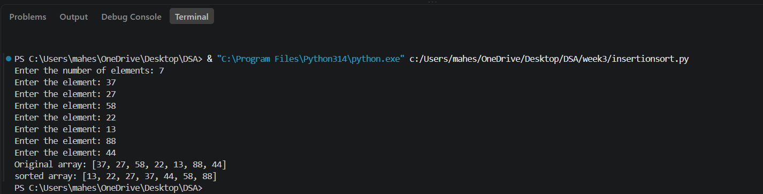
EXPLANATION:
- Insertion Sort is a comparison-based sorting algorithm.
- It builds the sorted array one element at a time.
- The algorithm starts from the second element of the array.
- The current element is stored in the variable key.
- It compares the key with the elements before it.
- Larger elements are shifted one position to the right.
- The key is inserted into its correct position.
- This process continues until all elements are sorted.
- Its time complexity is O(n²) in the average and worst cases.
- The function returns the array sorted in ascending order.

ERROR TABLE:
Error | Correction
Indendation error | Give proper indendation
Negative input | Check that z>= 0 before running the loop.

3c) Write a python program to implement selection sort where the elements are taken from the user.
CODE:
def selection_sort(arr):
n = len(arr)
for i in range(n - 1):
min_index = i
for j in range(i + 1, n):
if arr[j] < arr[min_index]:
min_index = j
arr[i], arr[min_index] = arr[min_index], arr[i]
return arr
arr = []
z = int(input("Enter the number of elements: "))
for k in range(z):
arr.append(int(input("Enter the element: ")))
print("Sorted array:", selection_sort(arr))
OUTPUT:
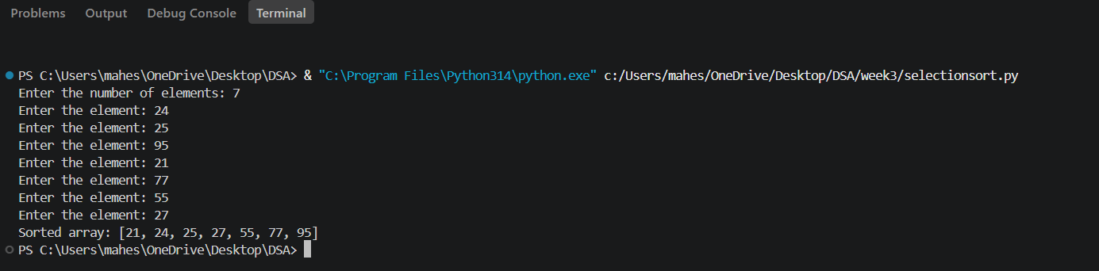
EXPLANATION:
- Selection Sort is a simple comparison-based sorting algorithm.
- It divides the array into a sorted part and an unsorted part.
- The algorithm starts from the first element of the array.
- It searches the unsorted part to find the smallest element.
- The index of the smallest element is stored in min_index.
- The smallest element is swapped with the first element of the unsorted part.
- This process is repeated until all elements are sorted.
- The algorithm sorts the given array in ascending order.
- Its time complexity is O(n²) in the best, average, and worst cases.
- The function returns the sorted array after completing the sorting process.

ERROR TABLE:
No error

WEEK-4
4a) Write a Python program to perform Merge Sort on a given list of elements.
Program: -
def merge_sort(arr):
if len(arr) > 1:
mid = len(arr) // 2
L = arr[:mid]
R = arr[mid:]
merge_sort(L)
merge_sort(R)
i = j = k = 0
while i < len(L) and j < len(R):
if L[i] <= R[j]:
arr[k] = L[i]
i += 1
else:
arr[k] = R[j]
j += 1
k += 1
while i < len(L):
arr[k] = L[i]
i += 1
k += 1
while j < len(R):
arr[k] = R[j]
j += 1
k += 1
return arr
a = []
while True:
elem = input("Enter an element (or enter stop to finish):- ")
if elem.lower() == "stop":
break
a.append(int(elem))
print("Original List:", a)
sorted_list = merge_sort(a)
print("Sorted List: ", sorted_list)
Output: -
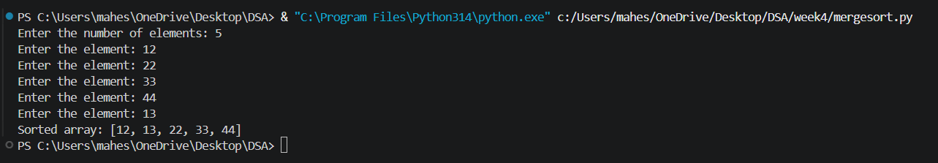
Explanation:
This program uses the Merge Sort technique to sort elements in a list using recursion.
- The function merge_sort(arr) is defined to sort the given list arr.
- The condition if len(arr) > 1: checks whether the list has more than one element.
  - If not, the list is already sorted (base case).
- The list is divided into two halves:
  - mid = len(arr) // 2 finds the middle index.
  - L = arr[:mid] stores the left half.
  - R = arr[mid:] stores the right half.
- The function recursively calls itself on both halves using merge_sort(L) and merge_sort(R).
- Three variables i, j, and k are initialized to 0:
  - i → index for left sublist
  - j → index for right sublist
  - k → index for merged list
- A while loop compares elements of L and R:
  - The smaller element is placed into arr[k].
  - Corresponding indices are incremented.
- After one sublist is exhausted, remaining elements of the other sublist are copied using two separate while loops.
- The sorted elements are merged back into the original list arr.
- The function returns the sorted list.
- The user inputs elements into the list a until "stop" is entered.
- The original list is printed, followed by the sorted list after calling merge_sort(a).
Error Table:
S.No | Error Obtained | Rectification
01. | ValueError when non-integer input is entered | Ensure input is integer or handle using try-except
02. | Program fails for empty list | Check if list is empty before sorting
03. | Incorrect merging if indices (i, j, k) are not updated properly | Ensure all indices are incremented correctly
04. | High memory usage due to creating sublists (L and R) | Use optimized in-place merge sort if required

4b) Write a Python program to perform Quick Sort on a given list of elements.
Program:-
def quick_sort(arr, low=0, high=None):
if high is None:
high = len(arr) - 1
if low < high:
pivot = arr[high]
i = low - 1
for j in range(low, high):
if arr[j] <= pivot:
i += 1
arr[i], arr[j] = arr[j], arr[i]
arr[i + 1], arr[high] = arr[high], arr[i + 1]
pi = i + 1
quick_sort(arr, low, pi - 1)
quick_sort(arr, pi + 1, high)
return arr
a = []
while True:
elem = input("Enter an element (or enter stop to finish):- ")
if elem.lower() == "stop":
break
a.append(int(elem))
print("Original List:", a)
sorted_list = quick_sort(a)
print("Sorted List: ", sorted_list)
Output:-
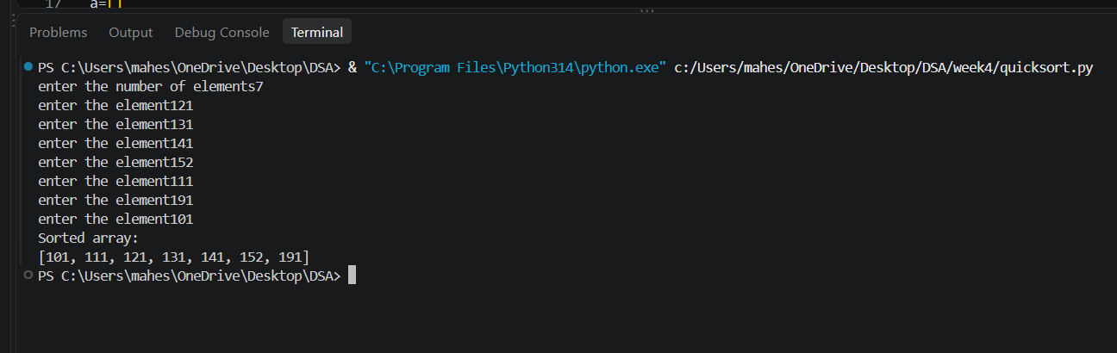
Explanation:
This program uses the Quick Sort technique to sort elements in a list using recursion.
- The function quick_sort(arr, low=0, high=None) is defined with parameters:
  - arr: The list to be sorted
  - low: Starting index (default 0)
  - high: Ending index (default last index of list)
- If high is None, it is initialized as len(arr) - 1.
- The condition if low < high: ensures that sorting is performed only when there are at least two elements.
- The last element arr[high] is chosen as the pivot.
- The variable i = low - 1 is used to track the position of smaller elements.
- A loop runs from j = low to high - 1:
  - If arr[j] <= pivot, i is incremented and elements are swapped using
arr[i], arr[j] = arr[j], arr[i].
- After the loop, the pivot is placed at its correct position using
arr[i + 1], arr[high] = arr[high], arr[i + 1].
- The pivot index pi = i + 1 divides the array into two parts.
- The function recursively sorts:
  - Left subarray → quick_sort(arr, low, pi - 1)
  - Right subarray → quick_sort(arr, pi + 1, high)
- The function returns the sorted list.
- The user inputs elements into list a until "stop" is entered.
- The original list and sorted list are printed.
Error Table:
S.No | Error Obtained | Rectification
01. | ValueError when non-integer input is entered | Ensure input is integer or handle using try-except
02. | Program fails for empty list | Check if list is empty before sorting
03. | Worst-case performance (O(n²)) for already sorted list | Use better pivot selection (e.g., middle or random pivot)
04. | Recursion depth error for very large lists | Increase recursion limit or use iterative approach

WEEK-5
5a) Write a Python program to implement a Singly Linked List with the following operations. Implement the above operations using a menu-driven program and a Node class.
Program: -
class Node:
def __init__(self,data):
self.data=data
self.next=None
class singlyLinkedList:
def __init__(self):
self.head=None
def create(self):
n=int(input("enter number of nodes:"))
for i in range(n):
data = int(input(f"enter data for node {i+1}:"))
new_node=Node(data)
if self.head is None:
self.head=new_node
else:
temp=self.head
while temp.next is not None:
temp = temp.next
temp.next=new_node
print("linked list is created successfully:")
def insert_beginning(self):
data = int(input("Enter data: "))
new_node = Node(data)
new_node.next = self.head
self.head = new_node
print("Node inserted at beginning.")
def insert_end(self):
data= int(input("enter data:"))
new_node=Node(data)
if self.head is None:
self.head=new_node
else:
temp=self.head
while temp.next is not None:
temp=temp.next
temp.next=new_node
print("Node inserted at end.")
def insert_position(self):
data = int(input("Enter data: "))
pos = int(input("Enter position: "))
new_node = Node(data)
if pos == 1:
new_node.next = self.head
self.head = new_node
print("Node inserted.")
return
temp = self.head
for i in range(1, pos - 1):
if temp is None:
print("Invalid position.")
return
temp = temp.next
if temp is None:
print("Invalid position.")
return
new_node.next = temp.next
temp.next = new_node
print("Node inserted at position", pos)
def delete_last(self):
if self.head is None:
print("list is empty")
return
if self.head.next is None:
self.head = None
print("Last node deleted.")
return
temp = self.head
while temp.next.next is not None:
temp = temp.next
temp.next = None
print("Last node deleted.")
def count_nodes(self):
count = 0
temp = self.head
while temp is not None:
count += 1
temp = temp.next
print("Number of nodes:", count)
def display(self):
if self.head is None:
print("List is empty.")
return
temp = self.head
print("Linked List:", end=" ")
while temp is not None:
print(temp.data, end=" -> ")
temp = temp.next
print("NULL")
def traverse(self):
if self.head is None:
print("List is empty.")
return
temp = self.head
print("Traversing the list:")
while temp is not None:
print(temp.data, end=" ")
temp = temp.next
print()
sll = singlyLinkedList()
while True:
print("\n----- SINGLY LINKED LIST -----")
print("1. Create")
print("2. Insert at beginning")
print("3. Insert at end")
print("4. Insert at specific position")
print("5. Delete by value")
print("6. Delete first node")
print("7. Delete last node")
print("8. Count number of nodes")
print("9. Display")
print("10. Traverse")
print("11. Exit")
choice = int(input("Enter your choice: "))
if choice == 1:
sll.create()
elif choice == 2:
sll.insert_beginning()
elif choice == 3:
sll.insert_end()
elif choice == 4:
sll.insert_position()
elif choice == 5:
sll.delete_by_value()
elif choice == 6:
sll.delete_first()
elif choice == 7:
sll.delete_last()
elif choice == 8:
sll.count_nodes()
elif choice == 9:
sll.display()
elif choice == 10:
sll.traverse()
elif choice == 11:
print("Exiting program...")
break
else:
print("Invalid choice. Please try again.")
Output: -
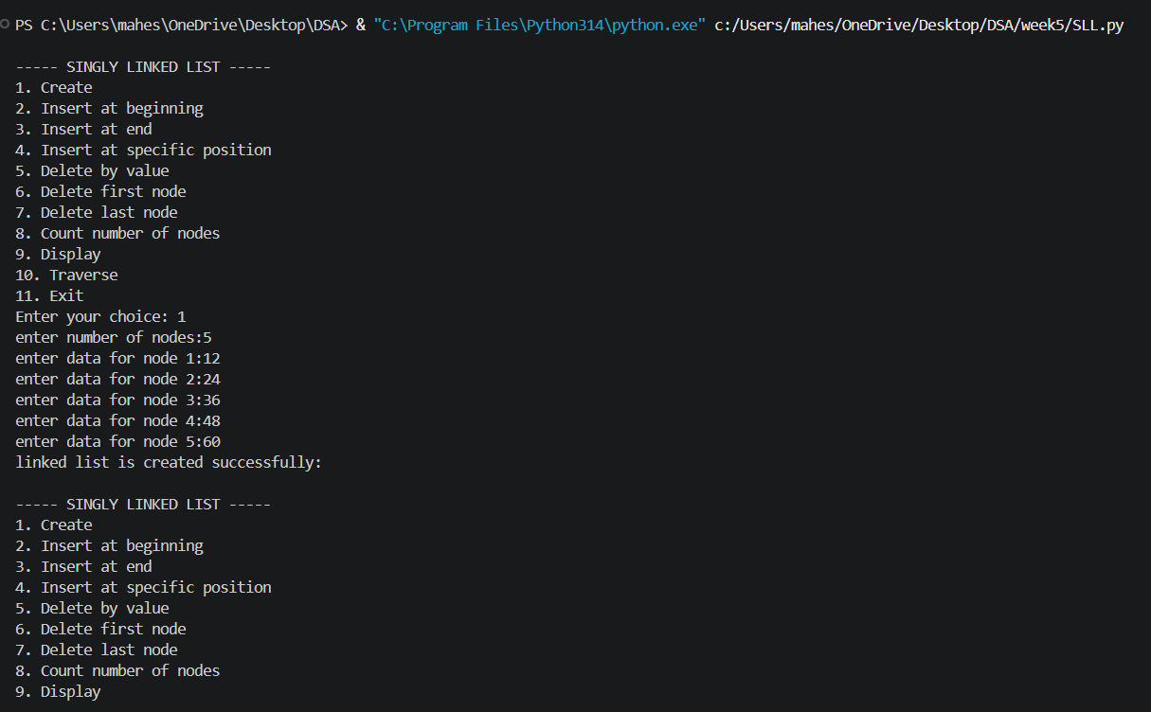

Explanation:
- The program implements a Singly Linked List using Node and SinglyLinkedList classes.
- Each node contains data and a next pointer that stores the reference to the next node.
- The head points to the first node of the linked list.
- The program supports insertion at the beginning, end, and a specific position.
- It supports deletion by value, from the beginning, and from the end.
- The count_nodes() function counts the total number of nodes.
- The display() function traverses and prints all nodes in the list.
- A menu-driven program is used to allow the user to select different operations.
ERROR TABLE:
S.NO | Error Obtained | Rectification
1. | Index out of range  When inserting/deleting at an index greater than the number of nodes. | Traverse carefully;  if temp becomes None before reaching index, print "Index out of range" and stop.
2. | Logical error in insertion  if index is negative. | Validate index: if index < 0: print ("Invalid index").
3. | Wrong output format  In display (missing None at end). | After traversal, always print "None" to mark end of list.
4. | Indentation Error  In the Count node part | It was rectified later,  By maintaining proper indentation.

5b) Write a Python program to implement a doubly Linked List with the following operations. Implement the above operations using a menu-driven program and a Node class.
Program:
class Node:
def __init__(self,data):
self.data=data
self.prev=None
self.next=None
class DoublyLinkedList:
def __init__(self):
self.head=None
def create(self):
n=int(input("enter the number of nodes"))
for i in range(n):
data = int(input(f"enter data for node{i+1}:"))
new_node= Node(data)
if self.head is None:
self.head=new_node
else:
temp = self.head
while temp.next is not None:
temp = temp.next
temp.next= new_node
new_node.prev=temp
print("doubly linked list created successfully")
def insert_beginning(self):
data = int(input("enter the data:"))
new_node=Node(data)
if self.head is None:
self.head=new_node
else:
new_node.next=self.head
self.head.prev=new_node
self.head = new_node
print("node inserted at beginning")
def insert_end(self):
data = int(input("Enter data: "))
new_node = Node(data)
if self.head is None:
self.head = new_node
else:
temp = self.head
while temp.next is not None:
temp = temp.next
temp.next = new_node
new_node.prev = temp
print("Node inserted at end.")
def insert_position(self):
data = int(input("Enter data: "))
pos = int(input("Enter position: "))
new_node = Node(data)
if pos == 1:
if self.head is not None:
new_node.next = self.head
self.head.prev = new_node
self.head = new_node
print("Node inserted at position", pos)
return
temp = self.head
for i in range(1, pos - 1):
if temp is None:
print("Invalid position.")
return
temp = temp.next
if temp is None:
print("Invalid position.")
return
new_node.next = temp.next
new_node.prev = temp
if temp.next is not None:
temp.next.prev = new_node
temp.next = new_node
print("Node inserted at position", pos)
def delete_by_value(self):
value = int(input("Enter value to delete: "))
if self.head is None:
print("List is empty.")
return
temp = self.head
while temp is not None and temp.data != value:
temp = temp.next
if temp is None:
print("Value not found.")
return
if temp == self.head:
self.head = temp.next
if self.head is not None:
self.head.prev = None
else:
temp.prev.next = temp.next
if temp.next is not None:
temp.next.prev = temp.prev
print("Node deleted.")
def delete_first(self):
if self.head is None:
print("List is empty.")
return
self.head = self.head.next
if self.head is not None:
self.head.prev = None
print("First node deleted.")
def delete_last(self):
if self.head is None:
print("List is empty.")
return
temp = self.head
if temp.next is None:
self.head = None
print("Last node deleted.")
return
while temp.next is not None:
temp = temp.next
temp.prev.next = None
print("Last node deleted.")
def count_nodes(self):
count = 0
temp = self.head
while temp is not None:
count += 1
temp = temp.next
print("Number of nodes:", count)
def display(self):
if self.head is None:
print("List is empty.")
return
temp = self.head
print("Doubly Linked List:", end=" ")
while temp is not None:
print(temp.data, end=" <-> ")
temp = temp.next
print("NULL")
def traverse(self):
if self.head is None:
print("List is empty.")
return
temp = self.head
print("Forward Traversal:", end=" ")
while temp is not None:
print(temp.data, end=" ")
temp = temp.next
print()
dll=DoublyLinkedList()
while True:
print("\n----- DOUBLY LINKED LIST -----")
print("1. Create")
print("2. Insert at beginning")
print("3. Insert at end")
print("4. Insert at specific position")
print("5. Delete by value")
print("6. Delete first node")
print("7. Delete last node")
print("8. Count number of nodes")
print("9. Display")
print("10. Traverse")
print("11. Exit")
choice = int(input("Enter your choice: "))
if choice == 1:
dll.create()
elif choice == 2:
dll.insert_beginning()
elif choice == 3:
dll.insert_end()
elif choice == 4:
dll.insert_position()
elif choice == 5:
dll.delete_by_value()
elif choice == 6:
dll.delete_first()
elif choice == 7:
dll.delete_last()
elif choice == 8:
dll.count_nodes()
elif choice == 9:
dll.display()
elif choice == 10:
dll.traverse()
elif choice == 11:
print("Exiting program...")
break
else:
print("Invalid choice. Please try again.")

Output:
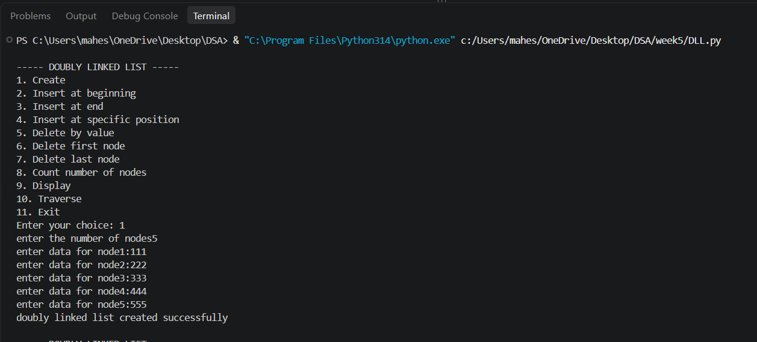
Explanation
- The program implements a Doubly Linked List using a Node class.
- Each node contains data, prev, and next references.
- The head points to the first node of the list.
- Nodes can be inserted at the beginning, end, or a specific position.
- Nodes can be deleted by value, from the beginning, or from the end.
- The program counts the nodes and displays the list in forward and backward directions.
ERROR TABLE:
S.NO | Error Obtained | Rectification
1. | Invalid index entered (negative or too large). | Add a check: if index < 0 → print "Invalid index"; if traversal reaches None before index → print "Index out of range".
2. | Deleting from an empty list. | Before deletion, check if self.head is None: → print "Doubly Linked List is empty."

5c) Write a Python program to implement a circular Linked List with the following operations. Implement the above operations using a menu-driven program and a Node class.
Program:
class Node:
def __init__(self,data):
self.data=data
self.next=None
class CircularLinkedList:
def __init__(self):
self.head=None
def create(self):
n=int(input("enter the number of nodes:"))
for i in range(n):
data = int(input(f"Enter data for node{i+1}:"))
new_node=Node(data)
if self.head is None:
self.head=new_node
new_node.next=self.head
else:
temp = self.head
while temp.next != self.head:
temp=temp.next
temp.next=new_node
new_node.next=self.head
print("circular Linked list is created succesfully")
def insert_beginning(self):
data = int(input("Enter data: "))
new_node = Node(data)
if self.head is None:
self.head = new_node
new_node.next = self.head
else:
temp = self.head
while temp.next != self.head:
temp = temp.next
new_node.next = self.head
temp.next = new_node
self.head = new_node
print("Node inserted at beginning.")
def insert_end(self):
data = int(input("Enter data: "))
new_node = Node(data)
if self.head is None:
self.head = new_node
new_node.next = self.head
else:
temp = self.head
while temp.next != self.head:
temp = temp.next
temp.next = new_node
new_node.next = self.head
print("Node inserted at end.")
def insert_position(self):
data = int(input("Enter data: "))
pos = int(input("Enter position: "))
new_node = Node(data)
if pos == 1:
if self.head is None:
self.head = new_node
new_node.next = self.head
else:
temp = self.head
while temp.next != self.head:
temp = temp.next
new_node.next = self.head
temp.next = new_node
self.head = new_node
print("Node inserted at position", pos)
return
if self.head is None:
print("Invalid position.")
return
temp = self.head
for i in range(1, pos - 1):
temp = temp.next
if temp == self.head:
print("Invalid position.")
return
new_node.next = temp.next
temp.next = new_node
print("Node inserted at position", pos)
def delete_by_value(self):
value = int(input("Enter value to delete: "))
if self.head is None:
print("List is empty.")
return
if self.head.data == value and self.head.next == self.head:
self.head = None
print("Node deleted.")
return
if self.head.data == value:
temp = self.head
while temp.next != self.head:
temp = temp.next
temp.next = self.head.next
self.head = self.head.next
print("Node deleted.")
return
prev = self.head
temp = self.head.next
while temp != self.head:
if temp.data == value:
prev.next = temp.next
print("Node deleted.")
return
prev = temp
temp = temp.next
print("Value not found.")
def delete_first(self):
if self.head is None:
print("List is empty.")
return
if self.head.next == self.head:
self.head = None
print("First node deleted.")
return
temp = self.head
while temp.next != self.head:
temp = temp.next
temp.next = self.head.next
self.head = self.head.next
print("First node deleted.")
def delete_last(self):
if self.head is None:
print("List is empty.")
return
if self.head.next == self.head:
self.head = None
print("Last node deleted.")
return
temp = self.head
while temp.next.next != self.head:
temp = temp.next
temp.next = self.head
print("Last node deleted.")
def count_nodes(self):
if self.head is None:
print("Number of nodes: 0")
return
count = 0
temp = self.head
while True:
count += 1
temp = temp.next
if temp == self.head:
break
print("Number of nodes:", count)
def display(self):
if self.head is None:
print("List is empty.")
return
temp = self.head
print("Circular Linked List:", end=" ")
while True:
print(temp.data, end=" -> ")
temp = temp.next
if temp == self.head:
break
print("(HEAD)")
def traverse(self):
if self.head is None:
print("List is empty.")
return
temp = self.head
print("Traversing the list:", end=" ")
while True:
print(temp.data, end=" ")
temp = temp.next
if temp == self.head:
break
print()
cll = CircularLinkedList()
while True:
print("\n----- CIRCULAR LINKED LIST -----")
print("1. Create")
print("2. Insert at beginning")
print("3. Insert at end")
print("4. Insert at specific position")
print("5. Delete by value")
print("6. Delete first node")
print("7. Delete last node")
print("8. Count number of nodes")
print("9. Display")
print("10. Traverse")
print("11. Exit")
choice = int(input("Enter your choice: "))
if choice == 1:
cll.create()

elif choice == 2:
cll.insert_beginning()
elif choice == 3:
cll.insert_end()
elif choice == 4:
cll.insert_position()
elif choice == 5:
cll.delete_by_value()
elif choice == 6:
cll.delete_first()
elif choice == 7:
cll.delete_last()
elif choice == 8:
cll.count_nodes()
elif choice == 9:
cll.display()
elif choice == 10:
cll.traverse()
elif choice == 11:
print("Exiting program...")
break
else:
print("Invalid choice. Please try again.")
Output:
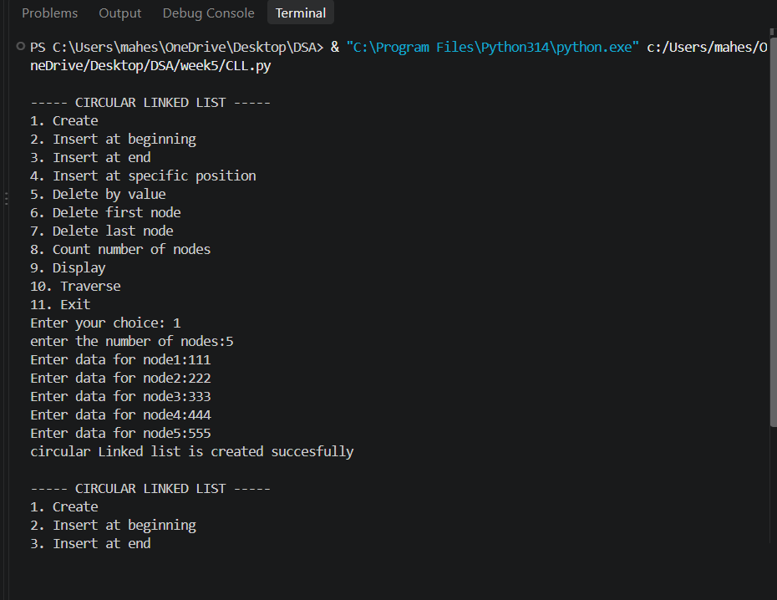
Explanation
- The program implements a Circular Linked List using a Node class.
- Each node contains data and a next reference.
- The last node points back to the head, forming a circular structure.
- Nodes can be inserted at the beginning, end, or a specific position.
- Nodes can be deleted by value, from the beginning, or from the end.
- The program counts the nodes and displays the list in head-to-tail and tail-to-head directions.
- A menu-driven approach is used to perform all the operations.

ERROR TABLE:
S.NO | Error Obtained | Rectification
1. | Display on empty list. | Add condition:  if self.head is None: → print "Circular Linked List is empty."
2. | Deleting from an empty list. | Before deletion, check if self.head is None: → print "Circular Linked List is empty."
3. |  | Ensure every insertion/deletion maintains circularity: last node’s next must always point to self.head.
  Infinite loop in traversal
  (if circularity broken).
4. | Reverse traversal  (Tail to Head) inefficient. | Current implementation repeatedly searches for predecessor. Rectify by using a doubly circular linked list if reverse traversal is frequent.

WEEK-6
6a) Write a python program to implement a stack using an Array Implement the stack operations such as push, pop, peak and also display the stack elements.
Program:
stack = []
max_size = 5
def push():
if len(stack) == max_size:
print("Stack Overflow")
else:
element = int(input("Enter element to push: "))
stack.append(element)
print(element, "pushed into stack")
def pop():
if len(stack) == 0:
print("Stack Underflow")
else:
element = stack.pop()
print(element, "popped from stack")
def peek():
if len(stack) == 0:
print("Stack is empty")
else:
print("Top element is:", stack[-1])
def display():
if len(stack) == 0:
print("Stack is empty")
else:
print("Stack elements are:")
for element in reversed(stack):
print(element)
while True:
print("\n--- STACK OPERATIONS ---")
print("1. Push")
print("2. Pop")
print("3. Peek")
print("4. Display")
print("5. Exit")
choice = int(input("Enter your choice: "))
if choice == 1:
push()
elif choice == 2:
pop()
elif choice == 3:
peek()
elif choice == 4:
display()
elif choice == 5:
print("Exiting...")
break
else:
print("Invalid choice")
Output:
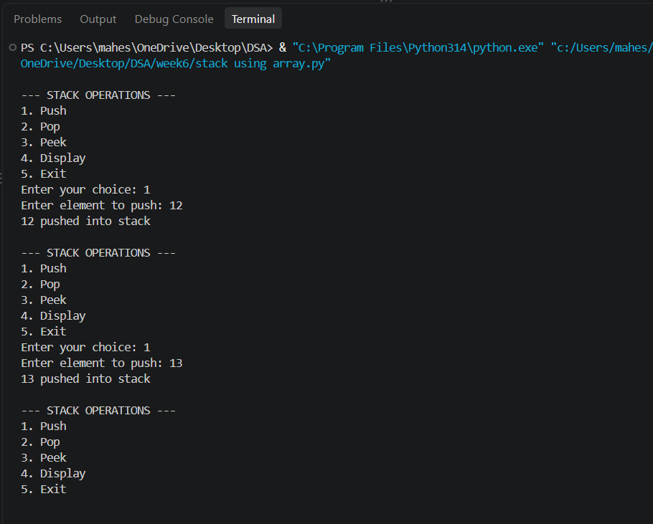
EXPLANATION:
Structure:
- Uses a Python list (self.stack) to store elements.
- self.top keeps track of the index of the last pushed element.
- self.size defines the maximum capacity.
Operations:
- Push
  - Check if top == size - 1 → Overflow.
  - Otherwise, increment top and insert the element at that position.
- Pop
  - Check if top == -1 → Underflow (empty stack).
  - Otherwise, remove the element at top, decrement top.
- Peek
  - Shows the element at top without removing it.
- Display
  - Prints elements from top down to 0 (top to bottom order).

ERROR TABLE:
S.NO | Error Obtained | Rectification
1. | def _init_(self, size): | Python expects two underscores before and after init.
2. | Display on empty stack. | Add condition: if self.top is None: → print  "Stack is empty".
3. |  | Add a check: if self.top == self.size - 1: → print "Stack Overflow".
  Stack Overflow
  when pushing beyond the defined size
4. | Stack Underflow  when popping from empty stack | Add a check: if self.top is None: → print "Stack Underflow".
5. | Syntax error | Later it was rectified in the for loop of display section.

6b) Write a python program to implement a stack using an Array Implement the stack operations such as push, pop, peak and also display the stack elements.
Program:
class Node:
def __init__(self, data):
self.data = data
self.next = None
class Stack:
def __init__(self):
self.top = None
def push(self, data):
new_node = Node(data)
new_node.next = self.top
self.top = new_node
print(data, "pushed into stack")
def pop(self):
if self.top is None:
print("Stack Underflow")
else:
data = self.top.data
self.top = self.top.next
print(data, "popped from stack")
def peek(self):
if self.top is None:
print("Stack is empty")
else:
print("Top element is:", self.top.data)
def display(self):
if self.top is None:
print("Stack is empty")
else:
temp = self.top
print("Stack elements are:")
while temp is not None:
print(temp.data)
temp = temp.next
stack = Stack()
while True:
print("\n--- STACK OPERATIONS ---")
print("1. Push")
print("2. Pop")
print("3. Peek")
print("4. Display")
print("5. Exit")

choice = int(input("Emter your choice: "))
if choice == 1:
element = int(input("Enter element to push: "))
stack.push(element)
elif choice == 2:
stack.pop()
elif choice == 3:
stack.peek()
elif choice == 4:
stack.display()
elif choice == 5:
print("Exiting...")
break
else:
print("Invalid choice")
Output:
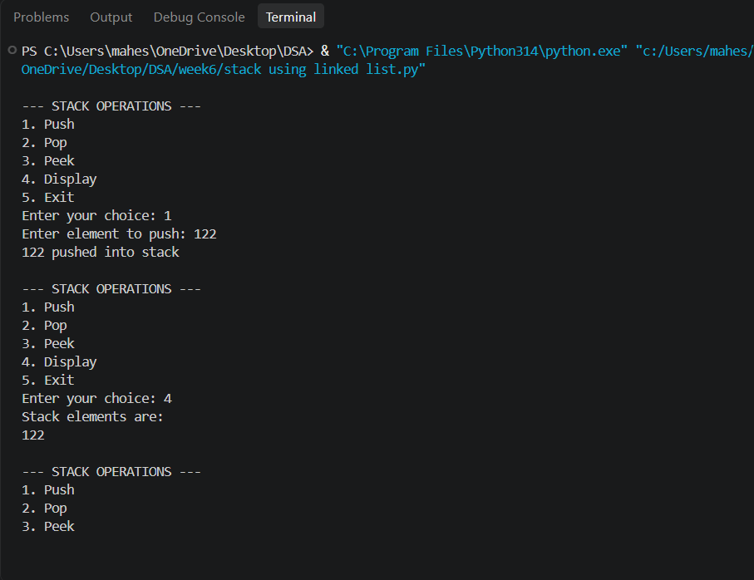
Explanation:
Structure:
- Each element is a Node with:
  - data (value)
  - next (pointer to the next node).
- self.top points to the most recently pushed node.
Operations:
- Push
  - Create a new node.
  - Link its next to the current top.
  - Update top to this new node.
- Pop
  - If top is None → Underflow.
  - Otherwise, remove the node at top and update top to top.next.
- Peek
  - Shows the data at top.
- Display
  - Traverse from top downwards, printing each node’s data.

ERROR TABLE:
S.NO | Error Obtained | Rectification
1. | def _init_(self, size): | Python expects two underscores before and after init.
2. | Display on empty stack. | Add condition: if self.top is None: → print  "Stack is empty".
3. |  | Add a check: if self.top == self.size - 1: → print "Stack Overflow".
  Stack Overflow
  when pushing beyond the defined size
4. | Stack Underflow  when popping from empty stack | Add a check: if self.top is None: → print "Stack Underflow".
5. | Syntax error | Later it was rectified in the for loop of display section.

WEEK-7
7a) write a python program to implement queue and its operation such as enqueue, dequeue, peek, and display with a menu driven approach using array and linked list data structures
Program:
array_queue = []
MAX_SIZE = 5
def array_enqueue():
if len(array_queue) == MAX_SIZE:
print("Array Queue Overflow")
else:
element = int(input("Enter element: "))
array_queue.append(element)
print(element, "inserted into Array Queue")
def array_dequeue():
if len(array_queue) == 0:
print("Array Queue Underflow")
else:
element = array_queue.pop(0)
print(element, "deleted from Array Queue")
def array_peek():
if len(array_queue) == 0:
print("Array Queue is empty")
else:
print("Front element:", array_queue[0])
def array_display():
if len(array_queue) == 0:
print("Array Queue is empty")
else:
print("Array Queue elements:")
for element in array_queue:
print(element, end=" ")
print()
class Node:
def __init__(self, data):
self.data = data
self.next = None
class LinkedQueue:
def __init__(self):
self.front = None
self.rear = None
def enqueue(self):
element = int(input("Enter element: "))
new_node = Node(element)
if self.rear is None:
self.front = self.rear = new_node
else:
self.rear.next = new_node
self.rear = new_node

print(element, "inserted into Linked List Queue")
def dequeue(self):
if self.front is None:
print("Linked List Queue Underflow")
else:
element = self.front.data
self.front = self.front.next
if self.front is None:
self.rear = None
print(element, "deleted from Linked List Queue")
def peek(self):
if self.front is None:
print("Linked List Queue is empty")
else:
print("Front element:", self.front.data)
def display(self):
if self.front is None:
print("Linked List Queue is empty")
else:
temp = self.front
print("Linked List Queue elements:")
while temp is not None:
print(temp.data, end=" ")
temp = temp.next
print()
linked_queue = LinkedQueue()
while True:
print("\n========== QUEUE IMPLEMENTATION ==========")
print("1. Queue using Array")
print("2. Queue using Linked List")
print("3. Exit")
choice = int(input("Enter your choice: "))
if choice == 1:
while True:
print("\n----- ARRAY QUEUE -----")
print("1. Enqueue")
print("2. Dequeue")
print("3. Peek")
print("4. Display")
print("5. Back to Main Menu")
ch = int(input("Enter your choice: "))
if ch == 1:
array_enqueue()
elif ch == 2:
array_dequeue()
elif ch == 3:
array_peek()
elif ch == 4:
array_display()
elif ch == 5:
break
else:
print("Invalid choice")
elif choice == 2:
while True:
print("\n----- LINKED LIST QUEUE -----")
print("1. Enqueue")
print("2. Dequeue")
print("3. Peek")
print("4. Display")
print("5. Back to Main Menu")
ch = int(input("Enter your choice: "))
if ch == 1:
linked_queue.enqueue()
elif ch == 2:
linked_queue.dequeue()
elif ch == 3:
linked_queue.peek()
elif ch == 4:
linked_queue.display()
elif ch == 5:
break
else:
print("Invalid choice")
elif choice == 3:
print("Exiting...")
break
else:
print("Invalid choice")
Output:
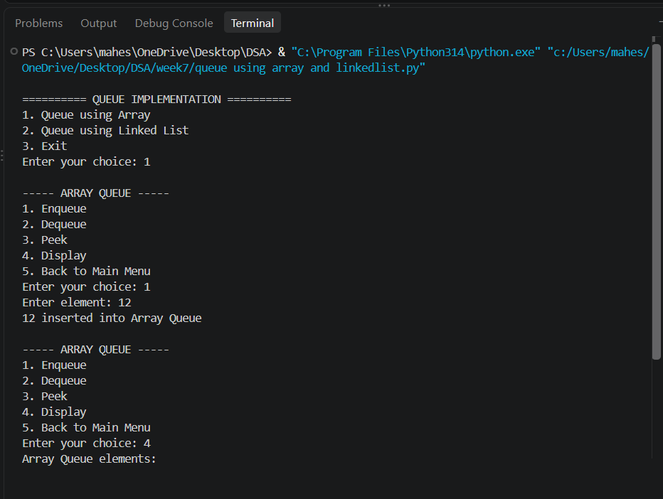
ERROR TABLE:
S.NO | Error Obtained | Rectification
1. | Array Queue Overflow | Prints overflow
2. | ValueError | Enter the correct value
3. | Slow array dequeue | Use a circular queue for efficient array implementation
4. | Index error | Add proper boundary checks
5. | Syntax error | Later it was rectified in the for loop of display section.

7b) write a python program to implement queue and its operation such as enqueue, dequeue, peek, and display with a menu driven approach using circular queue.
Program:
array_queue = []
MAX_SIZE = 5
def array_enqueue():
if len(array_queue) == MAX_SIZE:
print("Array Queue Overflow")
else:
element = int(input("Enter element: "))
array_queue.append(element)
print(element, "inserted into Array Queue")
def array_dequeue():
if len(array_queue) == 0:
print("Array Queue Underflow")
else:
element = array_queue.pop(0)
print(element, "deleted from Array Queue")
def array_peek():
if len(array_queue) == 0:
print("Array Queue is empty")
else:
print("Front element:", array_queue[0])
def array_display():
if len(array_queue) == 0:
print("Array Queue is empty")
else:
print("Array Queue elements:")
for element in array_queue:
print(element, end=" ")
print()
class Node:
def __init__(self, data):
self.data = data
self.next = None
class CircularQueue:
def __init__(self):
self.front = None
self.rear = None
def enqueue(self):
element = int(input("Enter element: "))
new_node = Node(element)
if self.front is None:
self.front = new_node
self.rear = new_node
self.rear.next = self.front
else:
new_node.next = self.front
self.rear.next = new_node
self.rear = new_node
print(element, "inserted into Circular Linked List Queue")
def dequeue(self):
if self.front is None:
print("Circular Queue Underflow")
# Only one node
elif self.front == self.rear:
element = self.front.data

self.front = None
self.rear = None
print(element, "deleted from Circular Linked List Queue")
else:
element = self.front.data
self.front = self.front.next
# Maintain circular connection
self.rear.next = self.front
print(element, "deleted from Circular Linked List Queue")
def peek(self):
if self.front is None:
print("Circular Queue is empty")
else:
print("Front element:", self.front.data)
def display(self):
if self.front is None:
print("Circular Queue is empty")
else:
print("Circular Linked List Queue elements:")
temp = self.front
while True:
print(temp.data, end=" ")
temp = temp.next
if temp == self.front:
break
print()
circular_queue = CircularQueue()
while True:
print("\n========== QUEUE IMPLEMENTATION ==========")
print("1. Queue using Array")
print("2. Queue using Circular Linked List")
print("3. Exit")
choice = int(input("Enter your choice: "))
if choice == 1:
while True:
print("\n----- ARRAY QUEUE -----")
print("1. Enqueue")
print("2. Dequeue")
print("3. Peek")
print("4. Display")
print("5. Back to Main Menu")
ch = int(input("Enter your choice: "))
if ch == 1:
array_enqueue()
elif ch == 2:
array_dequeue()
elif ch == 3:
array_peek()
elif ch == 4:
array_display()
elif ch == 5:
break
else:
print("Invalid choice")
elif choice == 2:
while True:
print("\n----- CIRCULAR LINKED LIST QUEUE -----")
print("1. Enqueue")
print("2. Dequeue")
print("3. Peek")
print("4. Display")
print("5. Back to Main Menu")
ch = int(input("Enter your choice: "))
if ch == 1:
circular_queue.enqueue()
elif ch == 2:
circular_queue.dequeue()
elif ch == 3:
circular_queue.peek()
elif ch == 4:
circular_queue.display()
elif ch == 5:
break
else:
print("Invalid choice")
elif choice == 3:
print("Exiting...")
break
else:
print("Invalid choice")

Output:
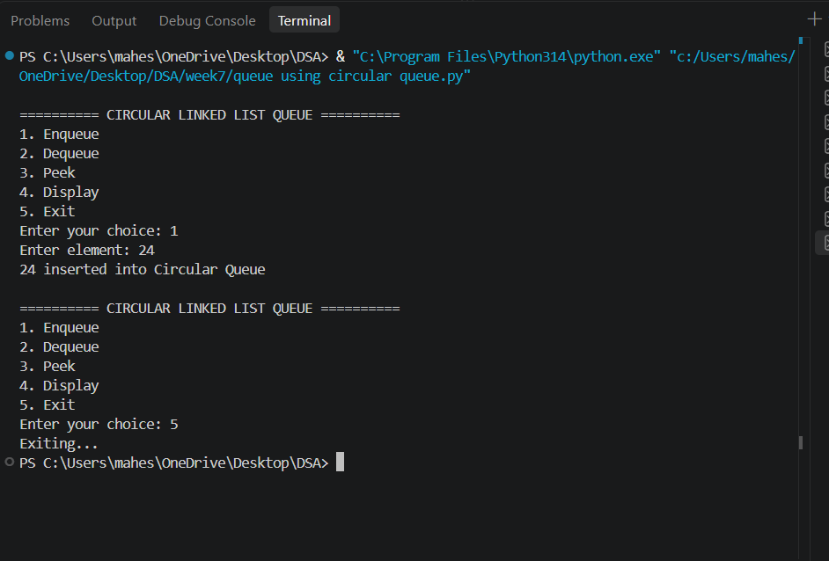
ERROR TABLE:
S.NO | Error Obtained | Rectification
1. | Array Queue Overflow | Prints overflow
2. | ValueError | Enter the correct value
3. | Slow array dequeue | Use a circular queue for efficient array implementation
4. | Index error | Add proper boundary checks
5. | Syntax error | Later it was rectified in the for loop of display section.

WEEK-8
8a. Write a python program to implement binary tree using array.
Code:
class BinaryTree:
def __init__(self, size):
self.tree = [None] * size
self.size = size
def set_root(self, data):
self.tree[0] = data
def set_left(self, parent_index, data):
child_index = 2 * parent_index + 1
if child_index < self.size:
self.tree[child_index] = data
else:
print("Index out of range")
def set_right(self, parent_index, data):
child_index = 2 * parent_index + 2
if child_index < self.size:
self.tree[child_index] = data
else:
print("Index out of range")
def preorder(self, index=0):
if index >= self.size or self.tree[index] is None:
return
print(self.tree[index], end=" ")
self.preorder(2 * index + 1)
self.preorder(2 * index + 2)
def inorder(self, index=0):
if index >= self.size or self.tree[index] is None:
return
self.inorder(2 * index + 1)
print(self.tree[index], end=" ")
self.inorder(2 * index + 2)
def postorder(self, index=0):
if index >= self.size or self.tree[index] is None:
return
self.postorder(2 * index + 1)
self.postorder(2 * index + 2)
print(self.tree[index], end=" ")
def level_order(self):
for value in self.tree:
if value is not None:
print(value, end=" ")
def display(self):
print("\nArray Representation:")
for i in range(self.size):
print(f"Index {i}: {self.tree[i]}")
tree = BinaryTree(7)
tree.set_root('A')
tree.set_left(0, 'B')
tree.set_right(0, 'C')
tree.set_left(1, 'D')
tree.set_right(1, 'E')
tree.set_right(2, 'F')
tree.display()
print("\nPreorder: ", end="")
tree.preorder()
print("\nInorder: ", end="")
tree.inorder()
print("\nPostorder: ", end="")
tree.postorder()
print("\nLevel-order: ", end="")
tree.level_order()
Output:
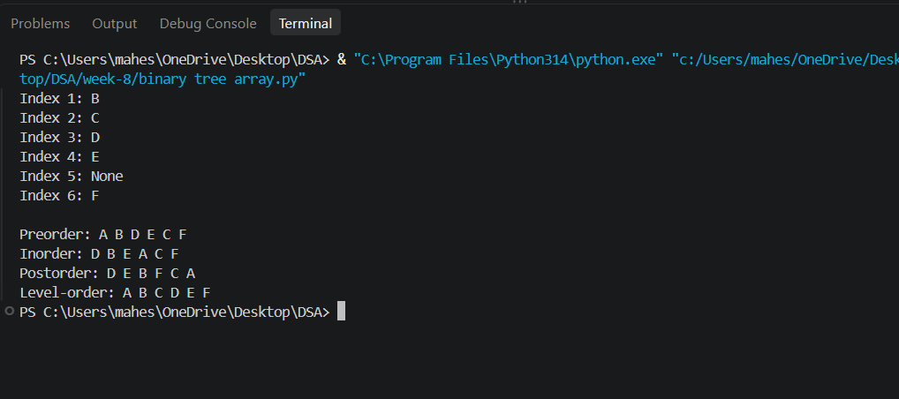
Explanation:
This Python code implements a binary tree using an array. The BinaryTree class creates a fixed-size list to store tree elements, with the root stored at index 0. For any node at index i, its left child is stored at 2*i + 1 and its right child at 2*i + 2. The set_root(), set_left(), and set_right() methods are used to insert elements into the tree. The preorder() method traverses the tree as Root → Left → Right, inorder() as Left → Root → Right, and postorder() as Left → Right → Root. The level_order() method displays the nodes level by level using the array representation. Finally, display() shows each array index and its corresponding value. Here, the tree contains A as the root, B and C as its children, and D, E, and F as the next-level nodes.
Error Table:
S.NO | Error Obtained | Rectification
1. | Array Queue Overflow | Add proper overflow condition before insertion.
2. | Syntax Error | Check the syntax, brackets, indentation, and correct the statement.
8b. Write a python program to implement binary tree using linked list.
Code:
class Node:
def __init__(self, data):
self.data = data
self.left = None
self.right = None
class BinaryTree:
def __init__(self):
self.root = None
def create_tree(self):
self.root = Node('A')
self.root.left = Node('B')
self.root.right = Node('C')
self.root.left.left = Node('D')
self.root.left.right = Node('E')
self.root.right.right = Node('F')
def preorder(self, node):
if node is None:
return
print(node.data, end=" ")
self.preorder(node.left)
self.preorder(node.right)
def inorder(self, node):
if node is None:
return
self.inorder(node.left)
print(node.data, end=" ")
self.inorder(node.right)
def postorder(self, node):
if node is None:
return
self.postorder(node.left)
self.postorder(node.right)
print(node.data, end=" ")
def level_order(self):
if self.root is None:
return
queue = [self.root]
while queue:
node = queue.pop(0)
print(node.data, end=" ")
if node.left is not None:
queue.append(node.left)
if node.right is not None:
queue.append(node.right)
tree = BinaryTree()
tree.create_tree()
print("Preorder: ", end="")
tree.preorder(tree.root)
print("\nInorder: ", end="")
tree.inorder(tree.root)
print("\nPostorder: ", end="")
tree.postorder(tree.root)
print("\nLevel-order: ", end="")
tree.level_order()

Output:
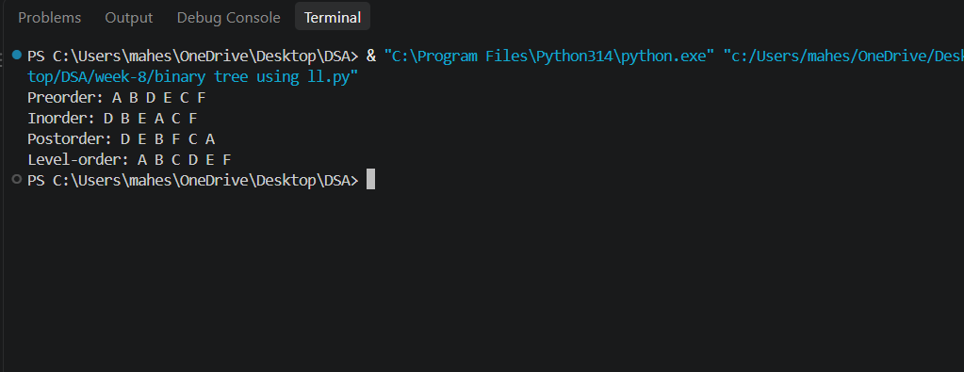
Explanation:
This Python code implements a binary tree using linked nodes. The Node class stores the data of each node along with references to its left and right children. The BinaryTree class maintains the root of the tree, and the create_tree() method creates a tree with A as the root, B and C as its children, and D, E, and F as the next-level nodes. The preorder() method traverses the tree in the order Root → Left → Right, while inorder() follows Left → Root → Right and postorder() follows Left → Right → Root. The level_order() method uses a queue to visit nodes level by level. The program finally calls each traversal method and displays the corresponding order of the nodes.
Error Table:
S.NO | Error Obtained | Rectification
1. | AttributeError | Ensure that the node is created correctly before accessing left or right.
2. | NoneType Error | Add a proper None check before performing operations on a node.
3. | Queue Empty Error | Check whether the queue contains elements before removing a node.
4. | Indentation Error | Maintain proper indentation inside classes, methods, loops, and conditional statements.

